Tuesday Ziyarat
Ziyarat of Imam Zainul Aabedeen, Imam Mohammad Baqir (a.s.) & Imam Jafar-e-Sadiq (a.s.)
O Allah! Send blessings on Muhammad and on the children of Muhammad.  In the name of Allah, the Beneficent, the Merciful.  Peace be on you, O depositories of Allah’s knowledge ! Peace be on you, O commentators of “Wahi” (revealed words of Allah)! Peace be on you, O rightly guided Guides unto the true way of life! Peace be on you, O symbols of devotion to duty ! Peace be on you, O descendants of the Messenger of Allah! I am aware of your true rights; look attentively at your refined disposition, full of joy, honour and dignity, take leave and go far away from your enemies, love dearly and keep company of your friends, with my father ( I am) at your disposal, and also my mother, blessings of Allah be on you.  O my Allah, I willingly submit (out of love and friendship) to all of them in unbroken succession, just as Thou appointed the first of them the “Mawlaa” and I am free from the guilt of taking shelter with any other save them, deny and curse “Jibt” and “taghoot” “Laat” and “Uzzaa” Blessings of Allah be on you  O my beloved Mawlaas! Mercy of Allah be on you, and His blessings. Peace be on you, O pride of worshippers (of Allah) (Zaynul A’abideen),the founder of the family of the successors (Imaams). Peace be on you, O (Baqir), he who inherited, knew, and enlarged the knowledge of the Prophets. Peace be on you O (Saadiq) truthful, his words were true, his deeds were good. O my Mawlaas! Today is your day, Tuesday, in its hours I take refuge with you, and seek your nearness, therefore receive me with open arms, and let me be near you, in the name and for the sake of your belief in Allah, and (belief)of your pure and pious family.  O Allah! Send blessings on Muhammad and on the children of Muhammad. |  | 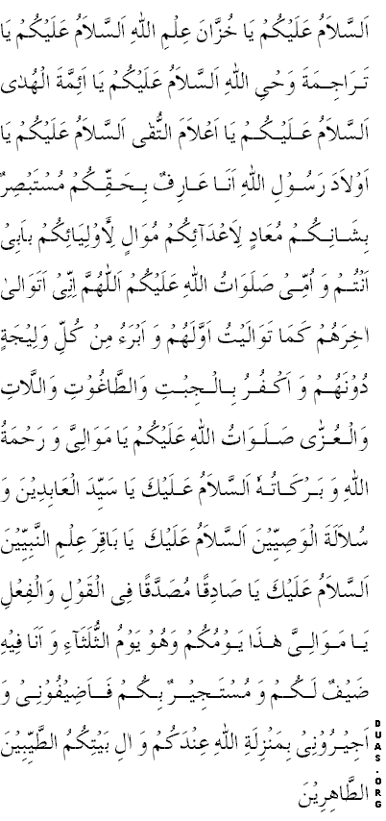

ALLAAHUMMA S’ALLI A’LAA MUH’AMMADIN’W WA AALI MUH’AMMAD
BISMILLAHIR-RAH’MAANIR-RAH’EEM
ASSAALAAMU A’LAYKUM YAA KHUZZAANA I’LMILAAH ASSALAAMU A’LAYKUM YAA KHUZZAANA I’LMILLAAH ASSALAAMU A’LAYKUM YAA TARAAJIMATA WAH’YILLAH ASSALAAMU A’LAYKUM YAAA A-IMMATAL HUDAA ASSALAAMU A’LAYKUM YAA AA’-LAAMAT TUQAA ASSALAAMU A’LYKUM YAA AWLADA RASOOLILLAAH ANAA A’ARIFUN BI-H’AQQIKUM MUSTABS’IRUN BI-SHAANIKUM MU-A’ADIN LI-AA’-DAAA-IKUM MUWAALIN LI-AWLIYAAA-IKUM BI-ABEE ANTUM WA UMMEE S’ALAWAATULLAAHI A’LAYKUM ALLAAHUMMA INNEE ATAWAALAA AAKHIRAHUM KAMAA TAWAALAYTU AWWALAHUM WA ABRA-U MIN KULLI WALEEJATIN DOONAHUM WA AKFURU BIL JIBTI WAT’TAAGHOOTI WAL LAATI WAL U’ZZAA S’ALAWATULLAAHI A’LAYKUM YAA MAWAALIYYAA WA RAH’MATULLAAHI WA BARAKAATUHOO ASSALAAMU A’LAYKA YAA SAYYIDAL A’ABIDEEN WA SULAALATAL WA’IYYEEN ASSALAAMU A’LAYKA YAA BAAQIRA I’LMUN NABIYYEEN ASSALAAMU A’LYKA YAA S’AADIQAN MUS’ADDAQAN’-FIL QAWLI WAL FIA’-LI YAA MAWAALIYYA HAAD’AA YAWMUKUM WA HUWA YAWMUTH THULATHAAA-I WA ANAA FEEHI Z”AYFUN LAKUM WA MUSTAJEERUN BIKUM FA-AZ”EEFOONEE WA AJEEROONEE BI-MANZILATILLAAHI I’NDAKUM W AALI BAYTIKUMUT’ TAYYIBEENAT’ T’AAHIREEN
ALLAHUMMA S’ALLI A’LAA MUH’AMMADIN’W WA AALI MUH’AMMAD

